**FIT 3077**

**Semester 1**

Team Information

**“Group Name”:**

Soo Guan Yin, Chua Jun Jie, Justin Chuah, Lim Fluoryynx

Table of Contents

Team Name 3

Team Photo 3

Team Membership 4

Team Schedule 4

Technology Stack and Justification 5

Potential Language/Framework for Frontend 5

ReactJS (JS + HTML) 5

JavaFX 5

Potential Language/Framework for Backend 5

Python 5

Java 5

Final Decision 6

Discarded Alternative 6

# Team Name

Torino Development United

# Team Photo

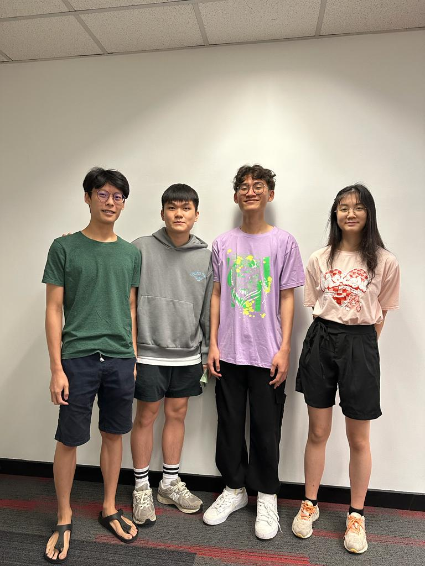

# Team Membership

|  |  |  |  |
| --- | --- | --- | --- |
| **Name** | **Contact Details** | **Technical and Professional Strength** | **Fun Fact** |
| Chua Jun Jie | **Email**:   jchu0057@student.monash.edu  **Phone**:  0177338896 | Comfortable using Python, Java, Javascript and HTML.  Can understand things in an easy and fast way. | Admitted to hospital after eating 5 fried chicken breasts. |
| Soo Guan Yin | **Email**:  gsoo0005@student.monash.edu  **Phone**:  0135339558 | Comfortable with using python, JavaScript and HTML.  Having more experience with backend development. | I like coffee.  Admitted to hospital after eating Korean spicy noodles. |
| Justin Chuah | **Email**:  jchu0056@student.monash.edu  **Phone**:  0122895924 | Comfortable with Python and Java. Able to pick up new concepts relatively well. | I share the same day of birth with one of the US presidents. |
| Lim Fluoryynx | **Email**:  flim0012@student.monash.edu  **Phone**:  0186695811 |  |  |

# Team Schedule

A scheduled meeting will be held on every Friday of the week. The purpose of the meeting is for each other to check up on another’s progress. If any team member is facing difficulties, he/she should voice out the difficulties during the meeting.

There also exists a team wiki document that is in Gitlab. The wiki is used for each team member to record their individual progression on the tasks they are working on. It consists of information such as task name, task assignee, total working hours etc. The wiki is updated regularly, at least once per week from the team. Furthermore, the team uses Trello for task tracking and monitoring. When the team member obtains a task, he/she should add the tasks into the Trello as well.

There is no fixed work schedule for the team members, but each team member is expected to make some progression each week.

# Technology Stack and Justification

## Potential Language/Framework for Frontend

### ReactJS (JS + HTML)

ReactJS is a robust platform used for building web applications. It comes with an extensive built-in library containing a diverse range of features that can be intricate and challenging to implement. However, this allows developers to save time in creating their applications as they don't have to create these features themselves. One of the drawbacks of using web-based applications is that the logic or backend of the application must be implemented in JavaScript, which doesn't comply with the requirements of the assignment as it is not an object-oriented programming language. A limitation of developing a web-based application is that it necessitates the installation of a browser on the client's device to access and run the application.

### JavaFX

JavaFX is a collection of graphics packages in Java that enables developers to build client-side applications. Its user interface is user-friendly and facilitates the creation of the application's user interface with ease. A significant advantage of using JavaFX to develop the application is that the application's logic or backend can be developed in Java, which satisfies the assignment's requirement of utilising an object-oriented programming language.

## Potential Language/Framework for Backend

### Python

Python is a versatile programming language that can be used for a wide range of tasks involving programming. It can be used to create both frontend UI and backend logic. All members of the team possess a strong knowledge of the language and are comfortable using it to develop applications. However, it doesn't completely meet the assignment requirement of utilising an object-oriented programming language. This is due to the fact that while Python only supports all the concepts of object-oriented programming, it is possible to write code without creating a class.

### Java

Java is a programming language that adheres strictly to the principles of object-oriented programming. Concepts such as encapsulation, abstraction, and inheritance from object-oriented programming help to safeguard the application against unwanted data access and function manipulation by the user. This enhances the security of the application. Finally, all team members have adequate knowledge of the language, which is sufficient to create a smaller scale application.

## Final Decision

From the comparison above, the team had chosen Java as the backend language to build the core logic of the application as Java adheres strictly to the principles of object-oriented programming. As for the creation of GUI of the application, the team believes that using JavaFX will decrease the time needed to develop the GUI of the application. Furthermore, the process of combining the frontend and backend of the application does not need to include any “middle man”, as both front and back end of the application uses the same language.

## Discarded Alternative

The decision to not use ReactJS as the frontend framework is based on the requirement for an external browser application to view and interact with the application. Additionally, when developing the backend logic with Java, an API must be used to communicate with the frontend side of the application.

Python is not being used as the backend language for developing the logic due to its incapability to fully follow the rules and concepts of object-oriented programming, which does not satisfy the assignment requirement of using object-oriented programming.